Kindergarten management System

Web programming class project 2021/2022

| Student Name in English | Student Name in Arabic | Student ID | Section | Work percentage |
| --- | --- | --- | --- | --- |
| Masa Hassan Masri | ماسه حسان مصري | 11923986 | 11-12.5 | 50% |
| Hadeel bani Jaber | هديل بني جابر | 11924091 | 11-12:30 | 50% |

Date/time

---------------------------------------------This section is intended for the Instructor---------------------------------------

| Topic | Mark |
| --- | --- |
| Project Idea |  |
| Project Complexity |  |
| Project Tools |  |
| Project Requirements and Modeling |  |
| Project Discussion |  |
| Project Completeness |  |
| Project Output Results or reporting |  |
| Project Administration and Management |  |
| Project Report |  |
| Team work |  |
|  |  |
|  |  |
|  |  |

2-abstract

As parents, we want the best for our kids. In today's climate, teacher to parent communication is more vital than ever. From naps and snacks, to magic moments or what happened when they tripped over in the garden and bumped their knee, parents have to always be a part of their child’s journey. As parents nowadays spend more time away from their kids, they need to be comfortable with a software that keeps them connected with their kids.

4- introduction

At our website, we have developed an interactive kindergarten management software that combines and simplifies administrative tasks. Recording children’s learning and development is as easy as ABC, and parent communication with staff is easy, effective and instant.

Also it reduces admin and paperwork by up to 70% and spends more time focusing on providing the best possible educational experiences for the children.

Sending secure messages to parents or staff ,sharing children’s daily activities, meals, naps and more with families, giving permissions for staff, and the ability of Updating the information improves communication.

3-Table of contents:

| Log in & sign out |
| --- |
| Home page as sponsor of the kindergarten containing some videos and features to encourage people to register |
| Separate profiles for each Staff, Administrator, Mom |
| Assign mom |
| Assign Staff and see/edit their info’s |
| Assign a child , with important info about him as dietary, medication, parents contact, birthdate, room name and more /edit info |
| Profile personal picture of each member. |
| Rooms section, view the staff in a specific room and children assigned to it. |
| Message with each member |
| live feed |
| Naps, start and end time |
| activities on general as learning and development |
| Photos, date & time of each activity |
| Moms can see their children profiles |
| Staff can see the specific children who they have to take care of in their room |
| Welcoming page for staff and mom |

5-project requirements

This Web application is a management software for a kindergarten and also to keep parents connected, and also it has a sponsor page. As management, the manager(admin) can sign up children after registering their mom, append staff to Rooms, See children and staff in a certain room, For Staff, they can create Feed for moms and admins to see how they are spending time with the kids and this by creating activity from options( Learning and development, Nap, Food and Drink, and more details with photos), each member of the kindergarten can send message to any other member as moms and staff. This Software also store the main information for a child that kindergarten needs such as Medication, Dietary, allergies, safe passphrase, contact of parents.

6- Tools used in the project

* Php storm
* XAMPP
* Bootstrap library

7-Project UML

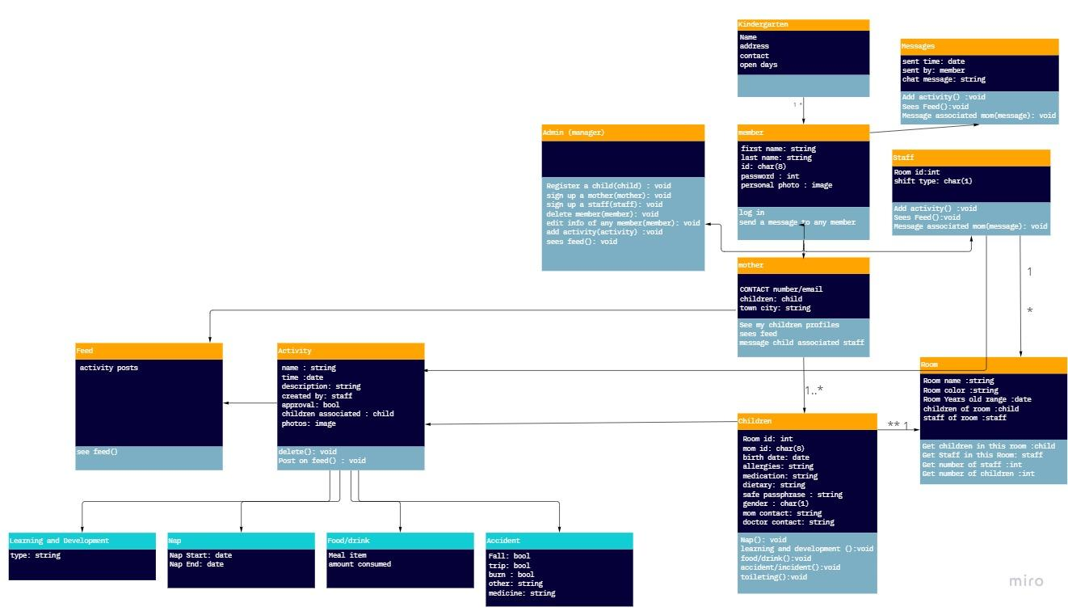

9-Discuss about GUI

1- the home page, this section contain some videos and photos from the kindergarten

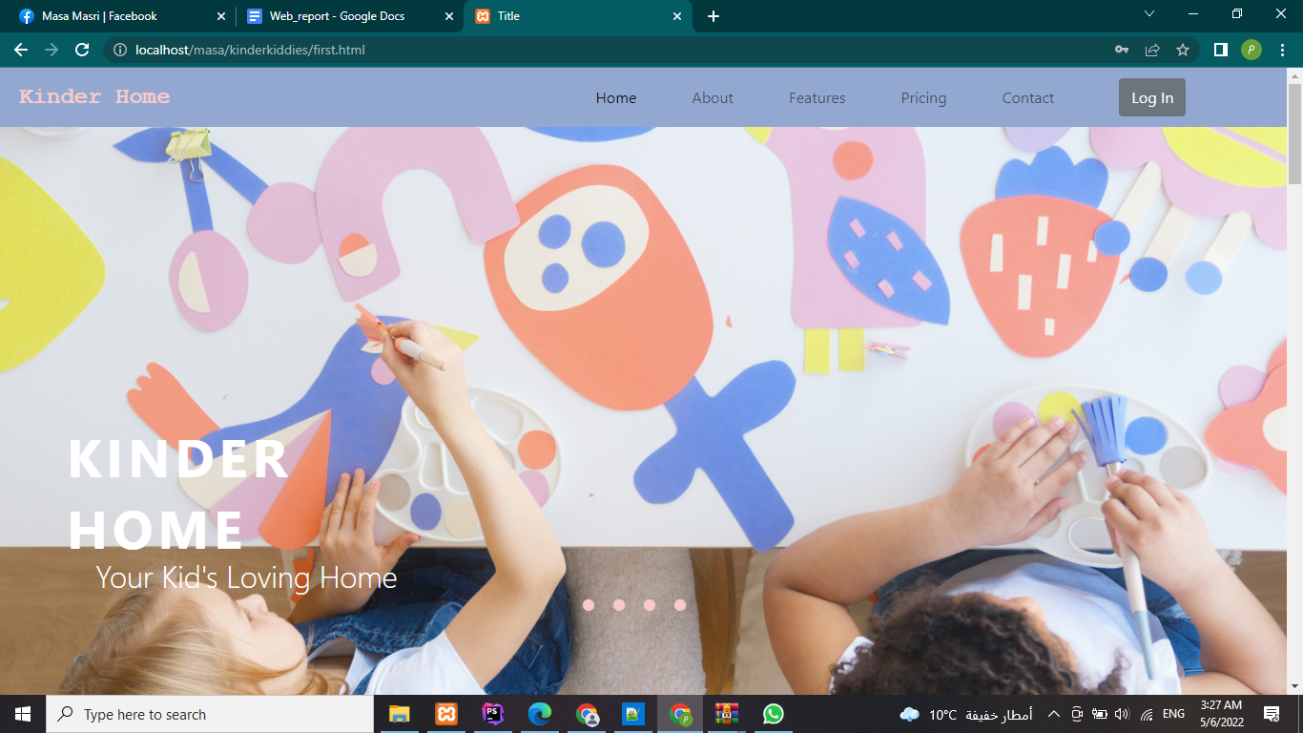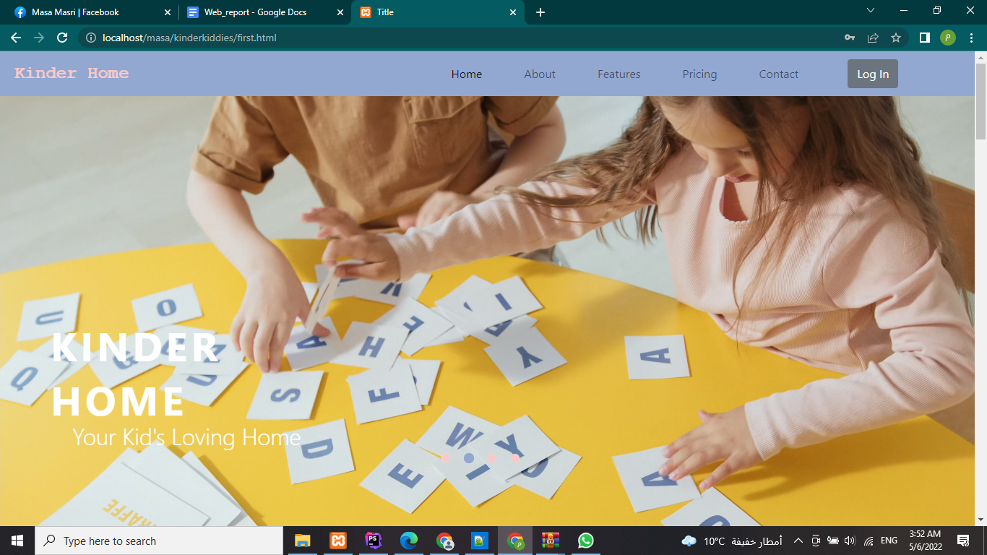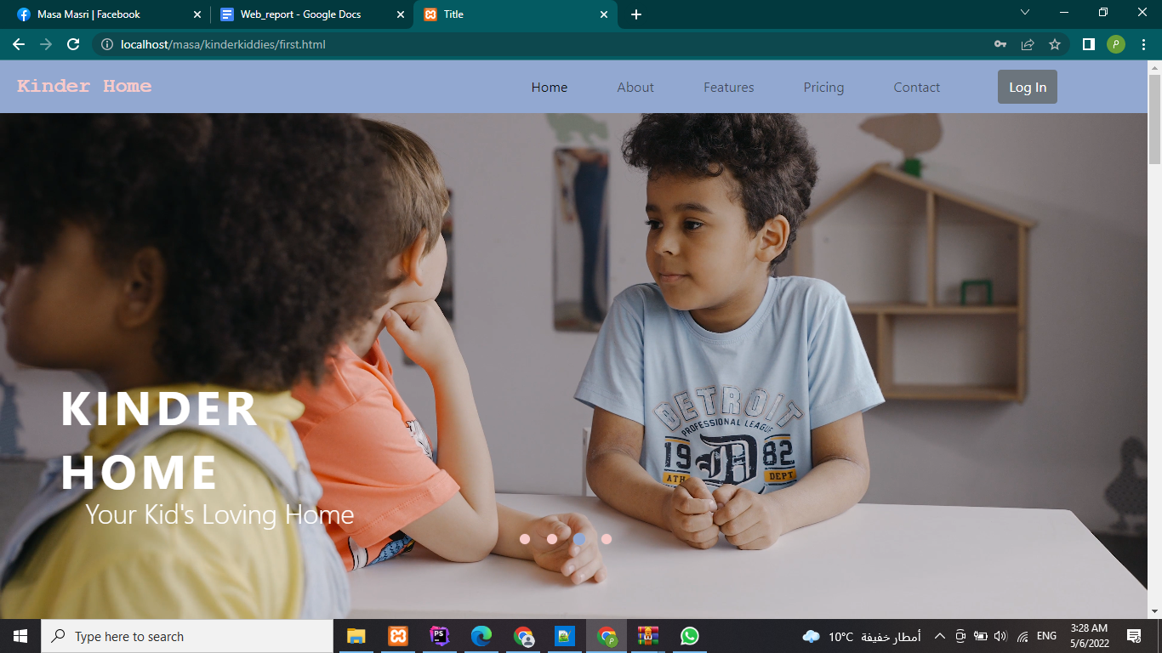and here’s to an abstract of the kindergarten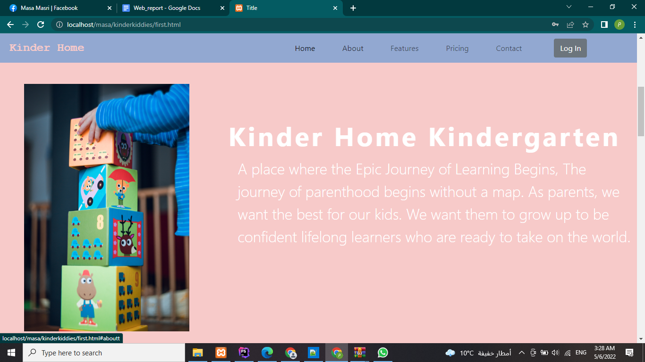Those are features of the software system.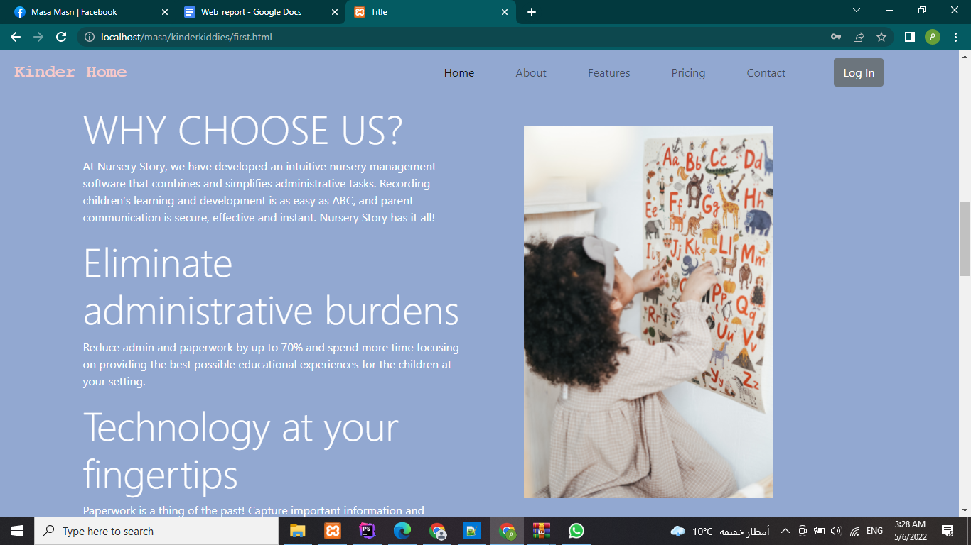features of the kindergarten and pricings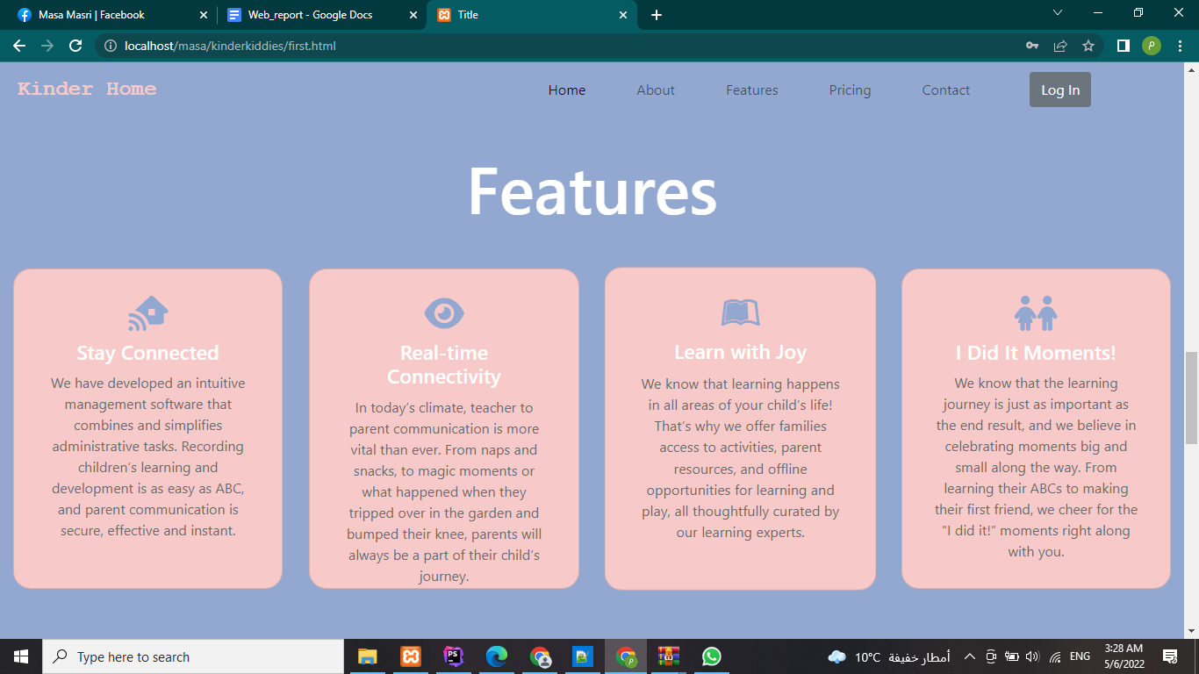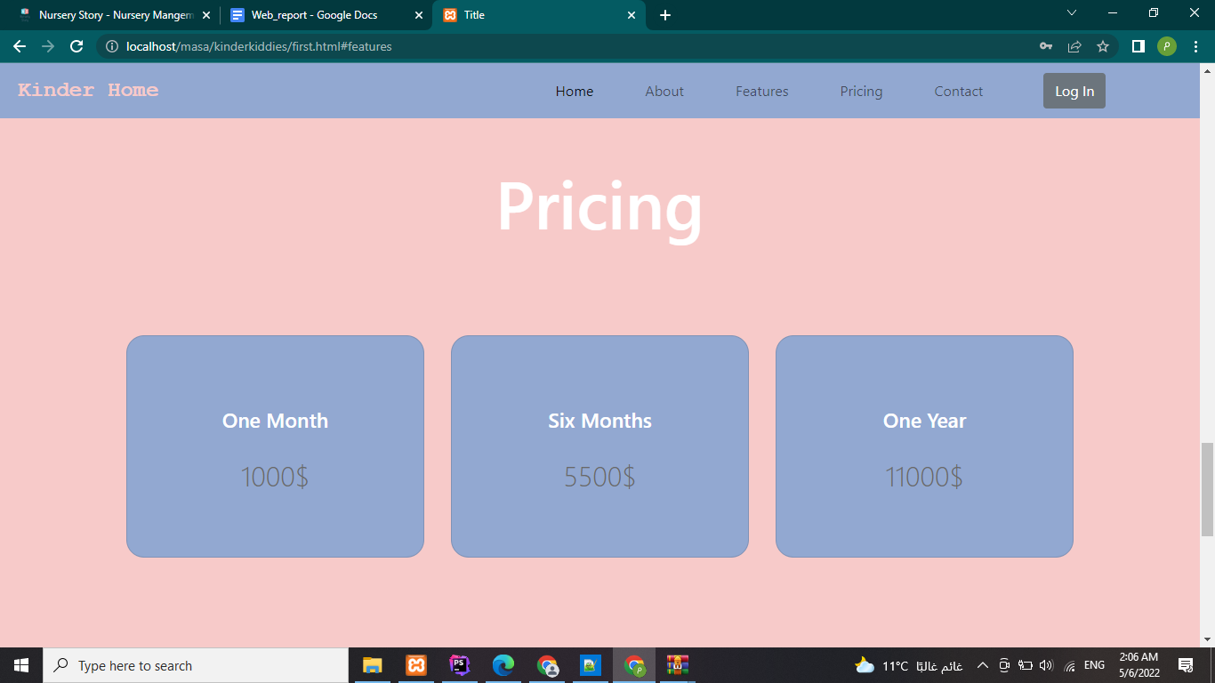developers section and some links about us with a footer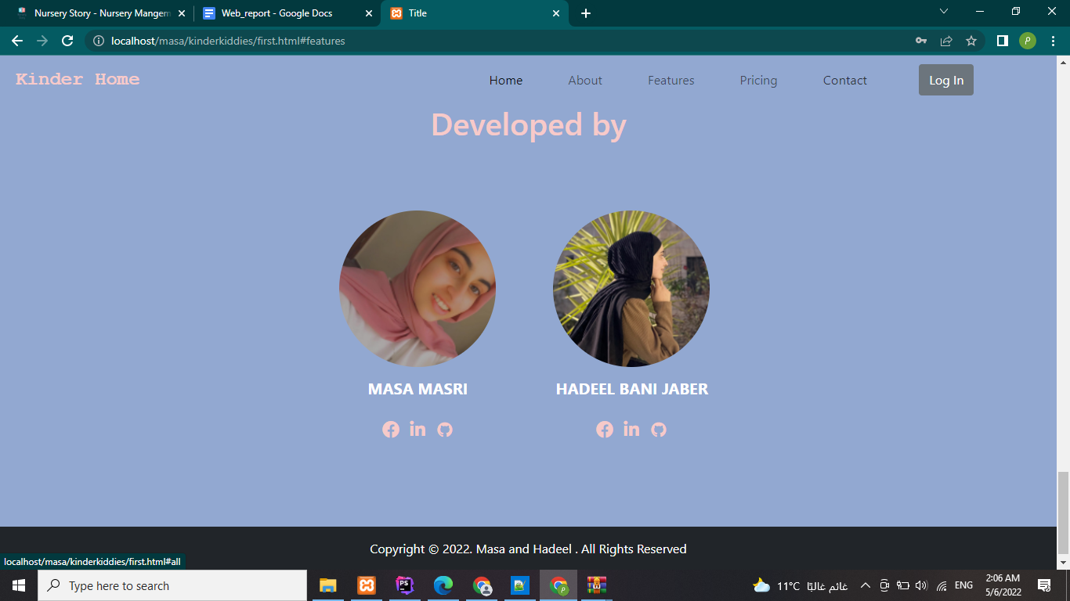log in within three types, Admin,staff,Mom, each head to a different page.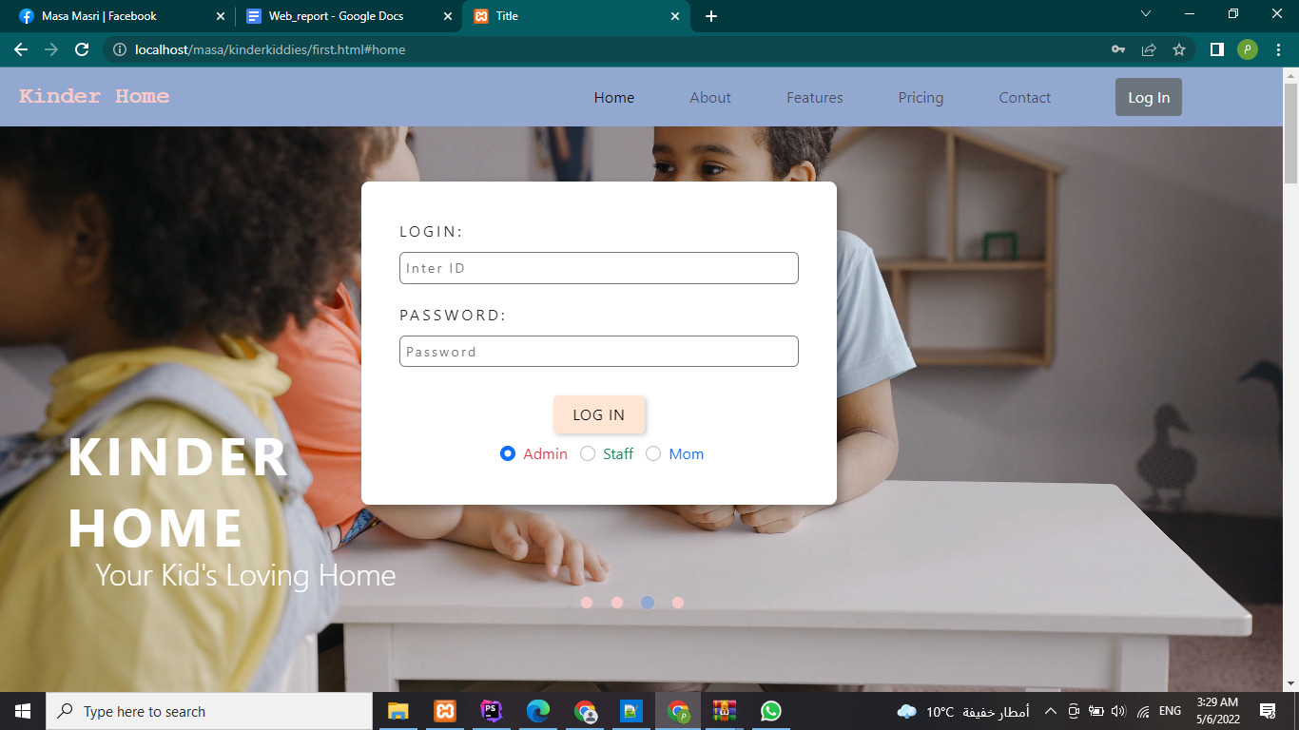1- logging in as Admin requires the admin’s id and password, use id =1 and password=1. 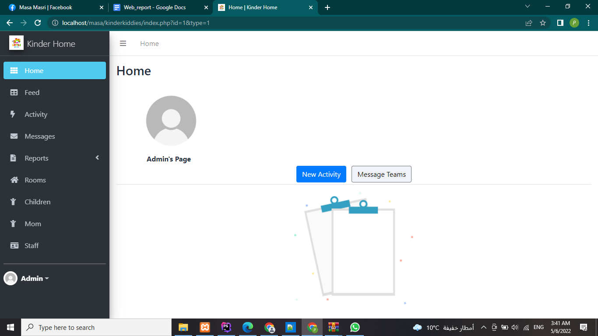

Mom’s section, Admin can register mom’s from this page by clicking on the plus icon

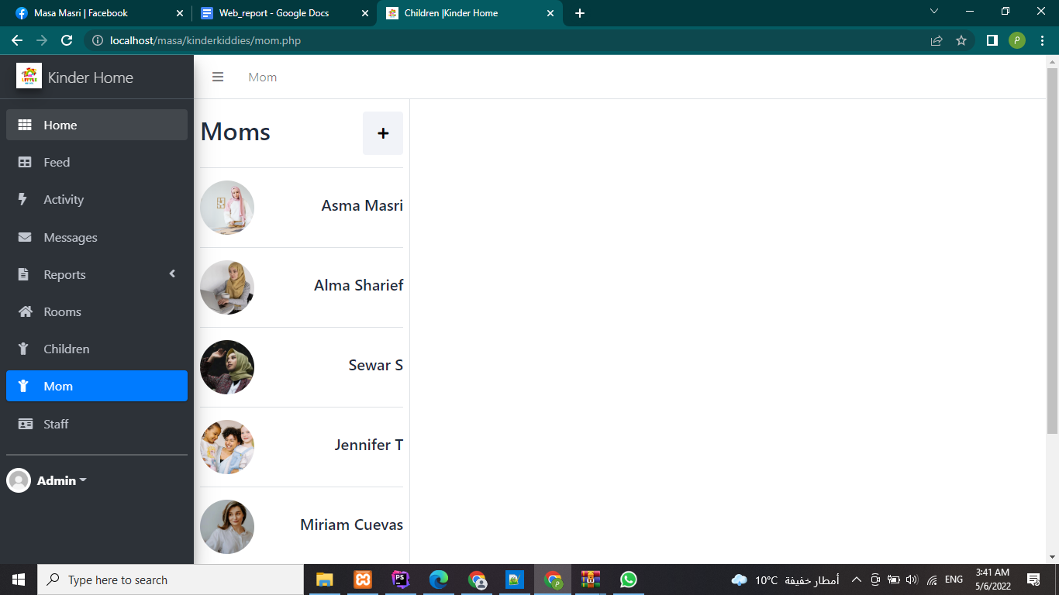

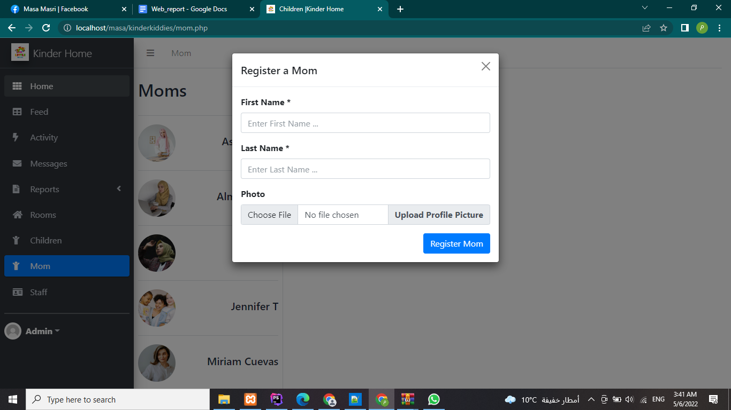Then you can register her children,the mom you just assigned will appear as an option in the dropdown menu.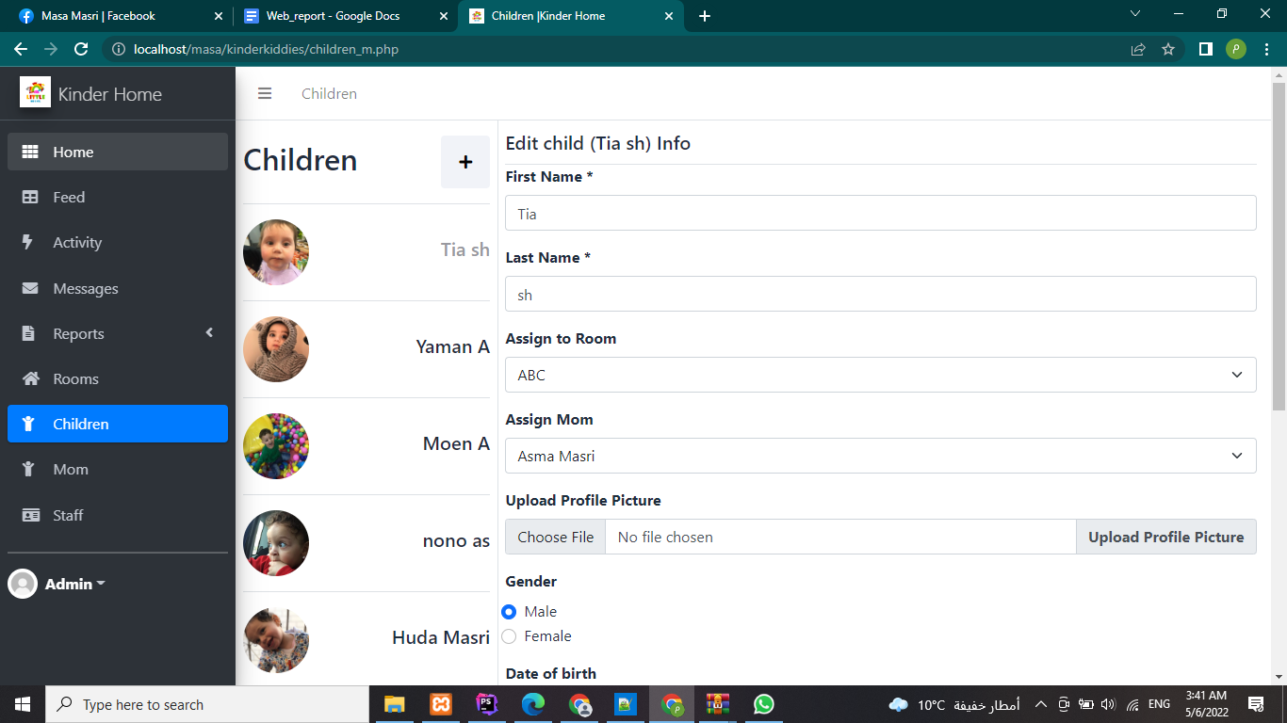for each child you add, you can then edit his info and add more details, or delete it. 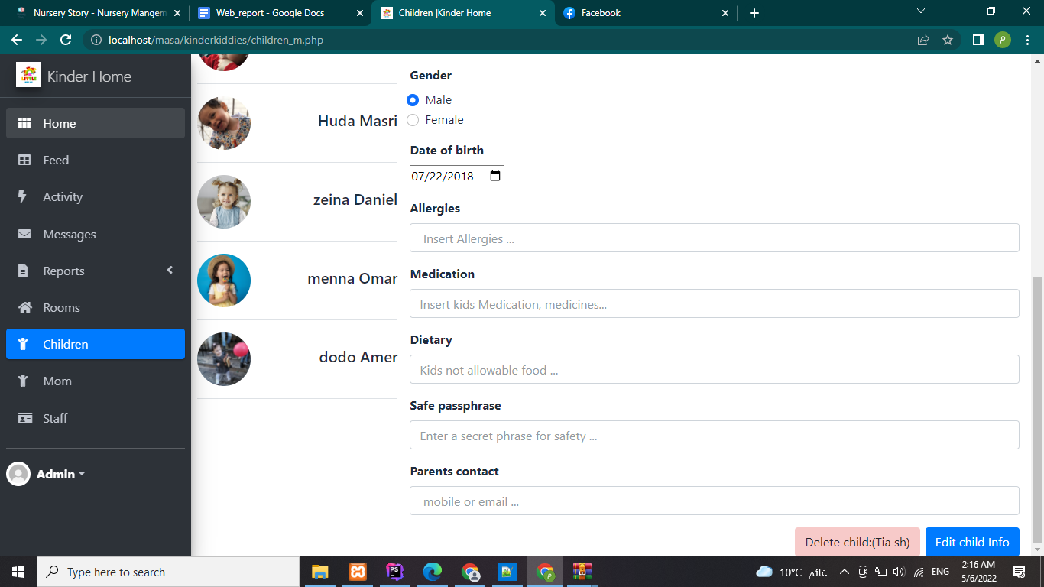

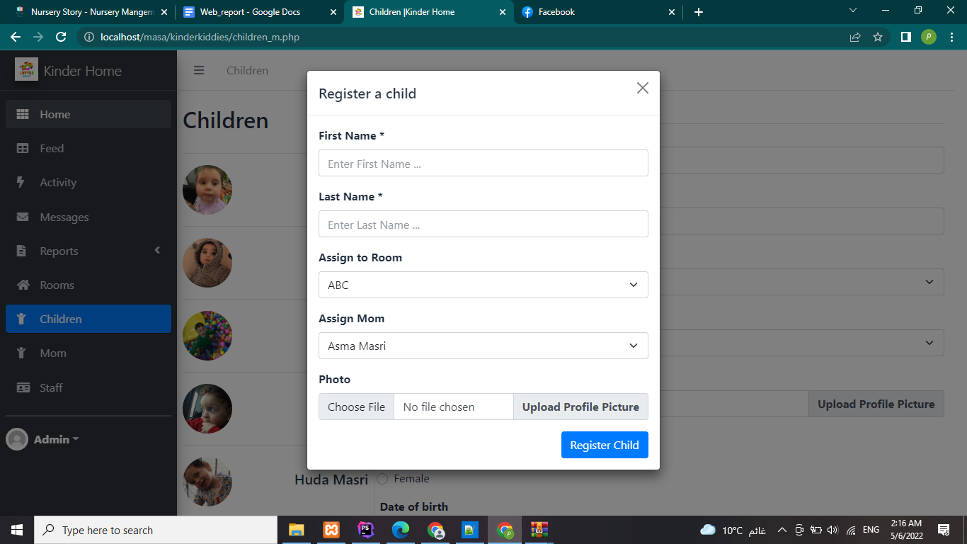from this page you can view all the staff in the nursery and edit their info or delete them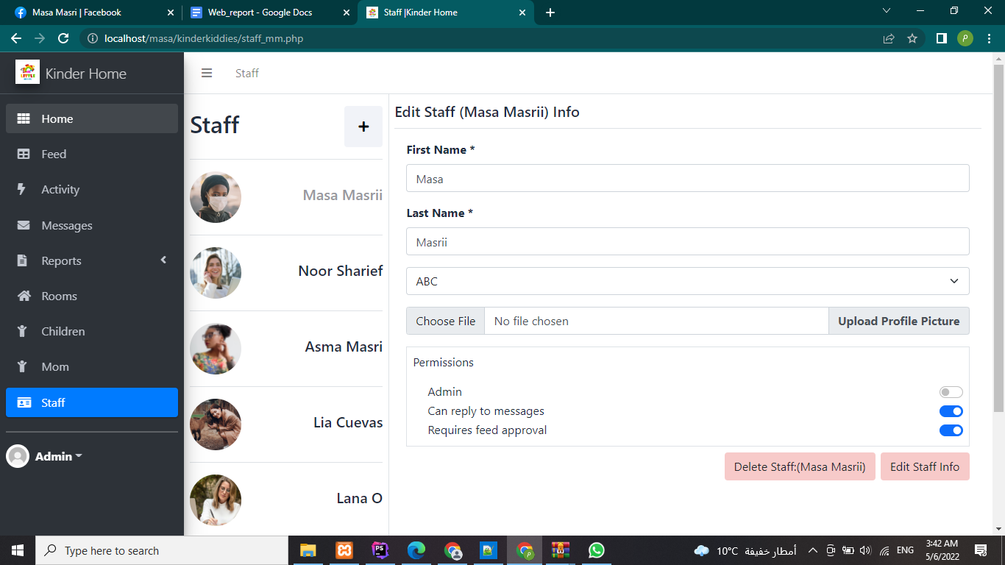assigning a new staff:

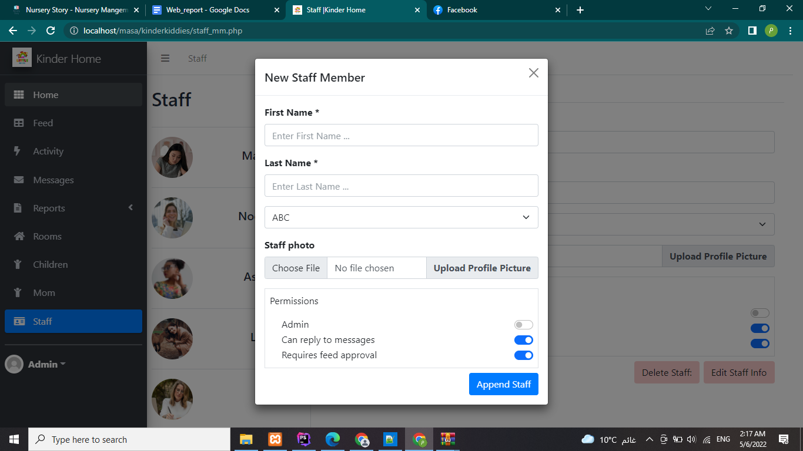

Messages section, the sender name will be set on the box by default (from the login info) for admin it is sent as admin.

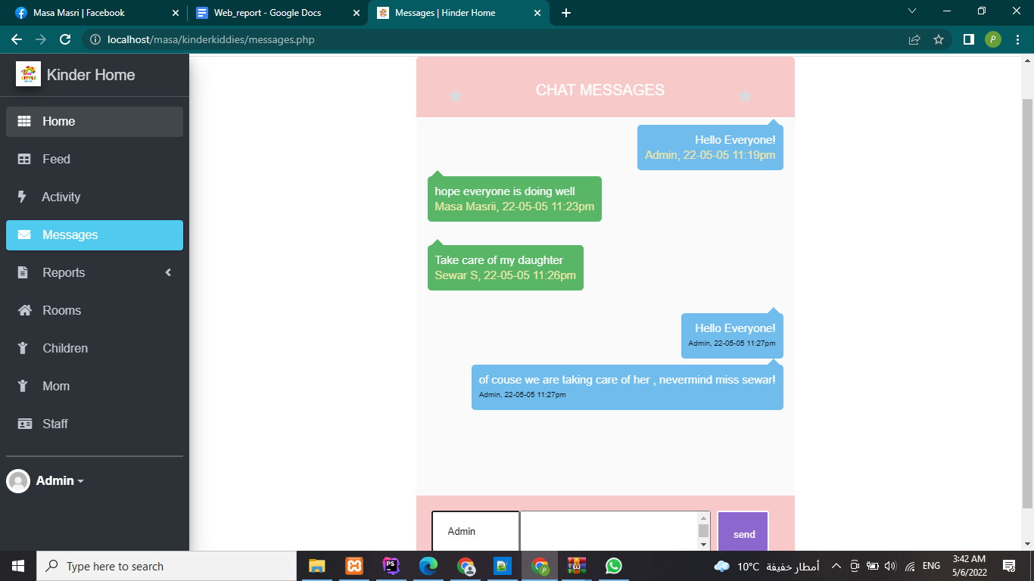

Adding activity:

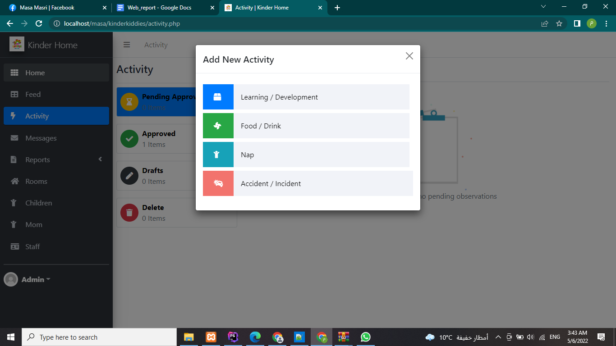first type of activity: eating or drinking, you can add a description and photos of meal all the children you registered will appear according to the database with a choice of the amount he consumed 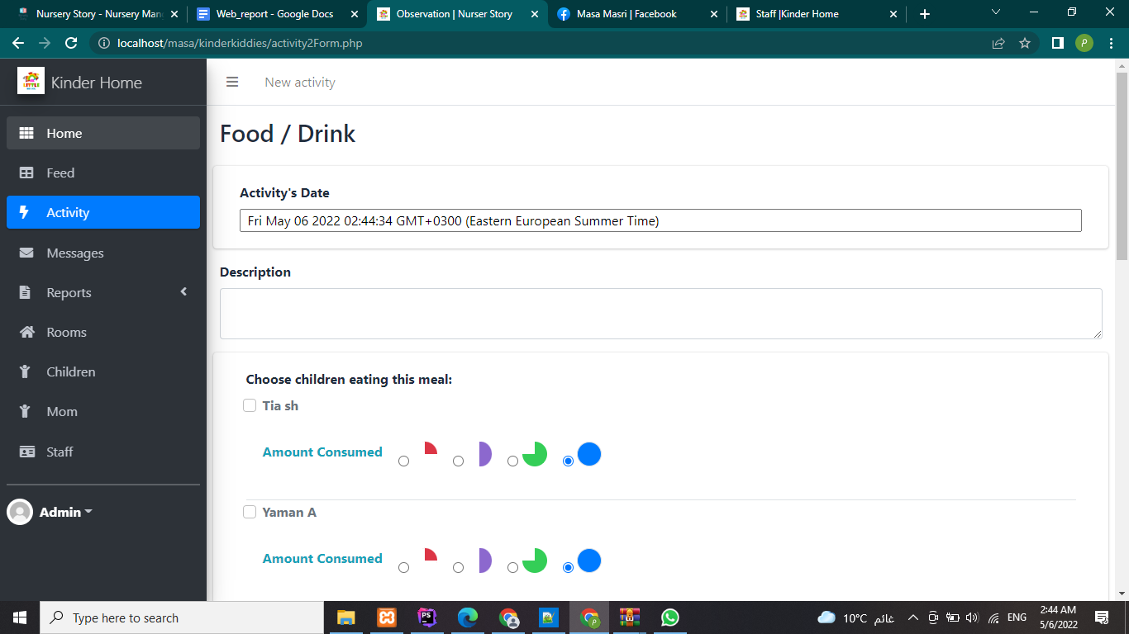

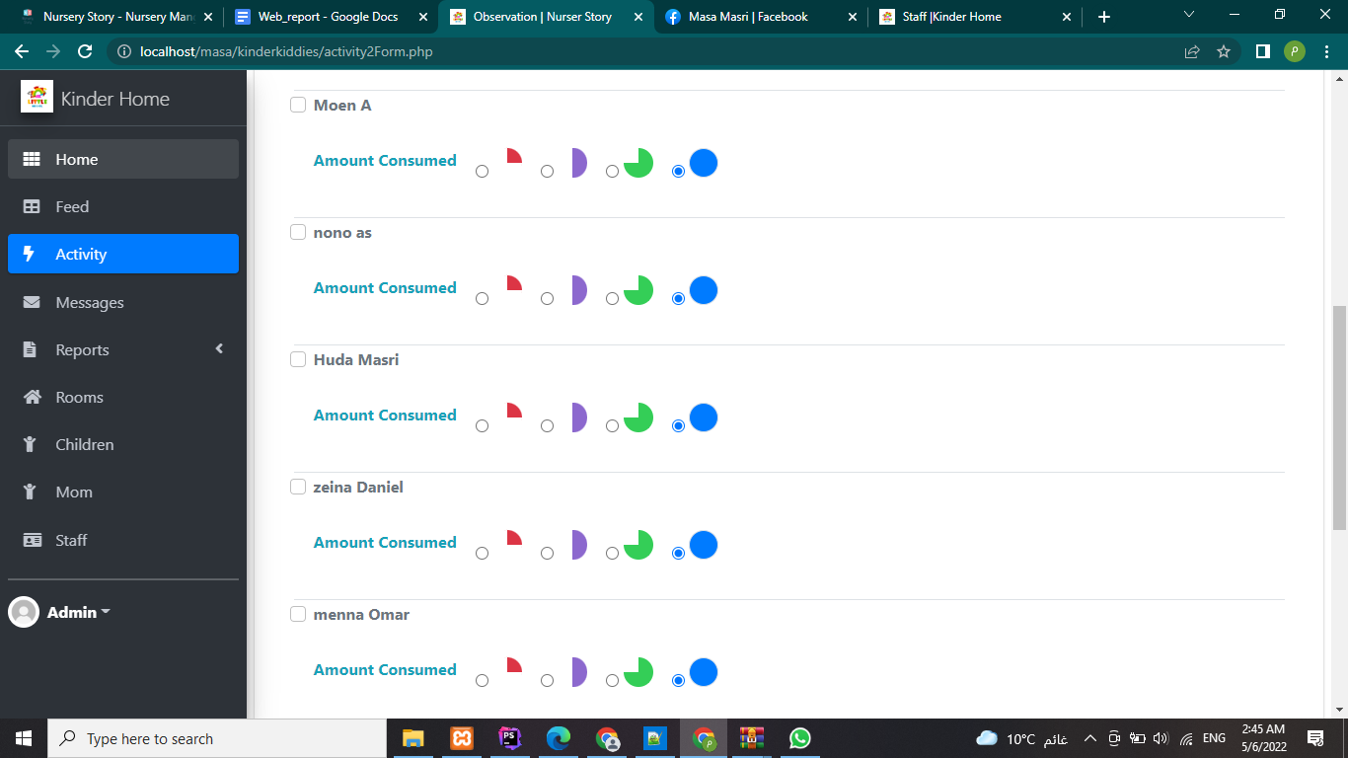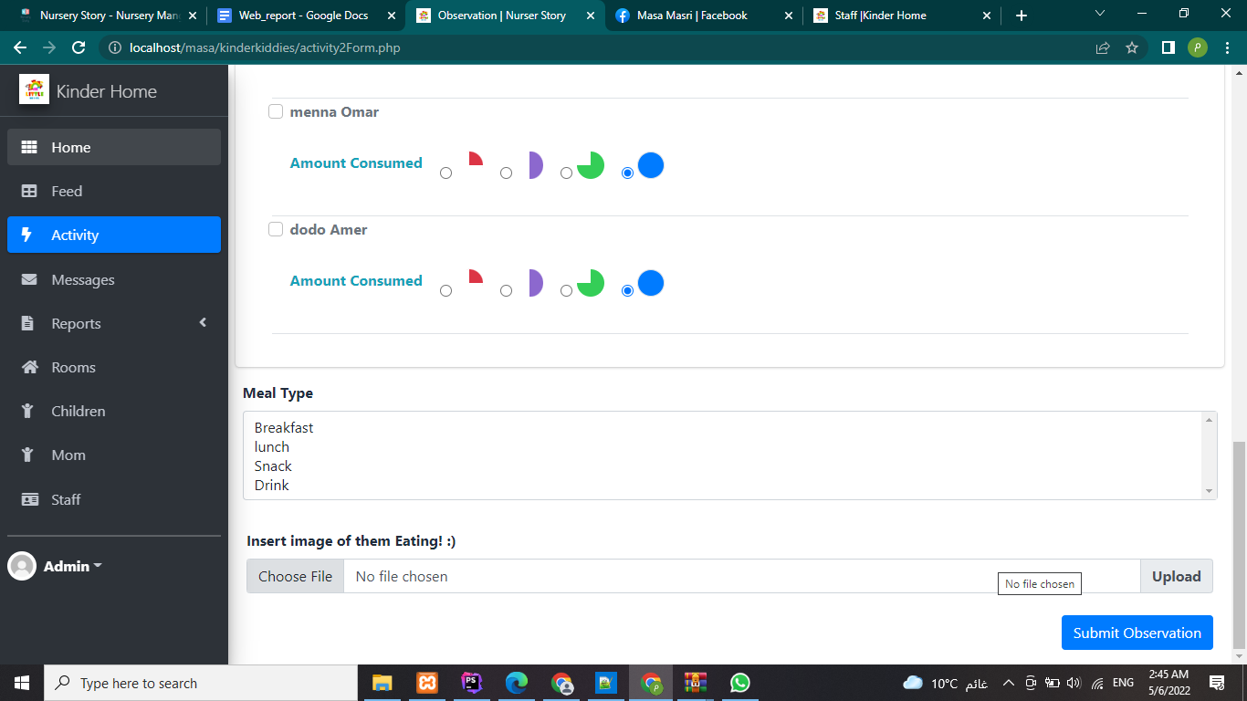then it will be added by default to the feed with this template following, moms can see it. 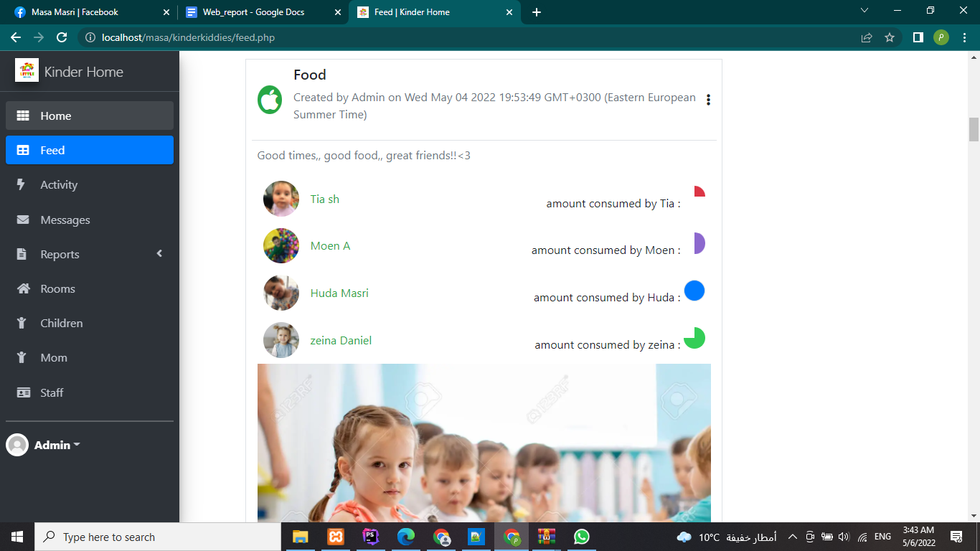the second activity is the nap, special in it is the starting and ending time of the nap 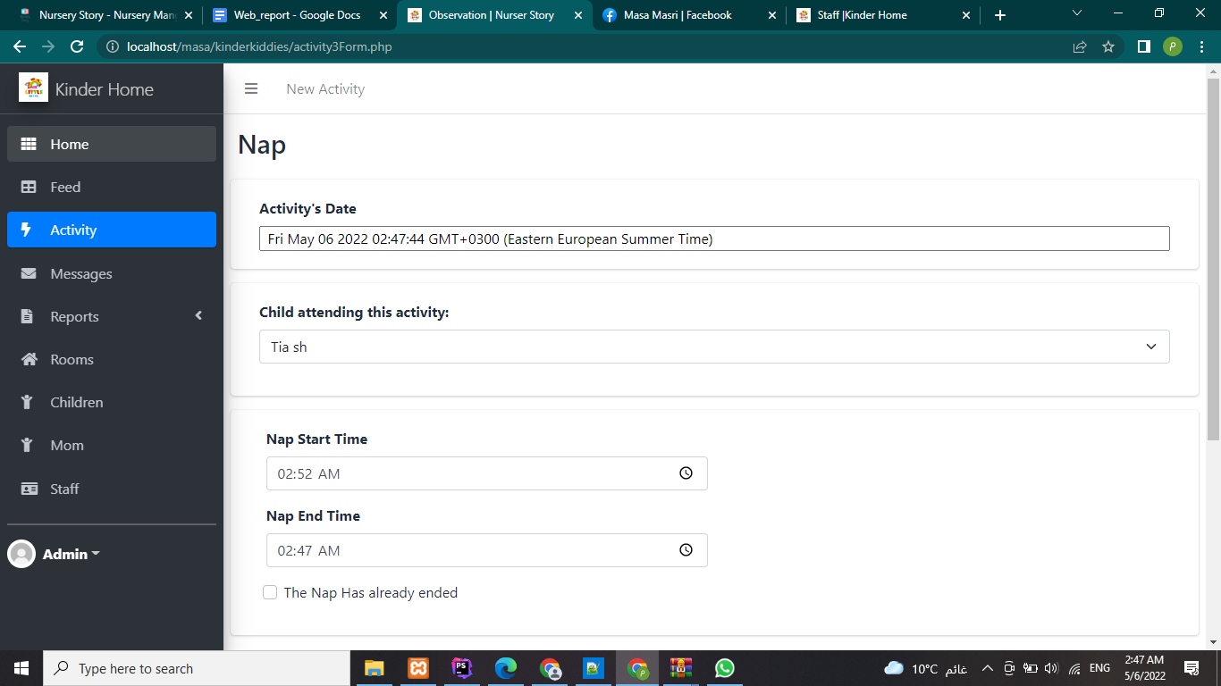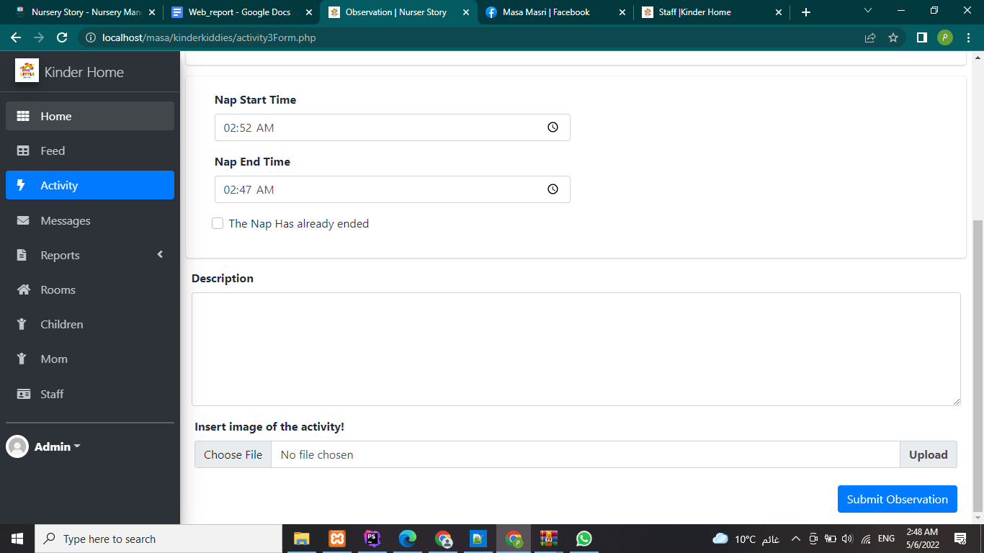then it heads you to the feed within this tempplate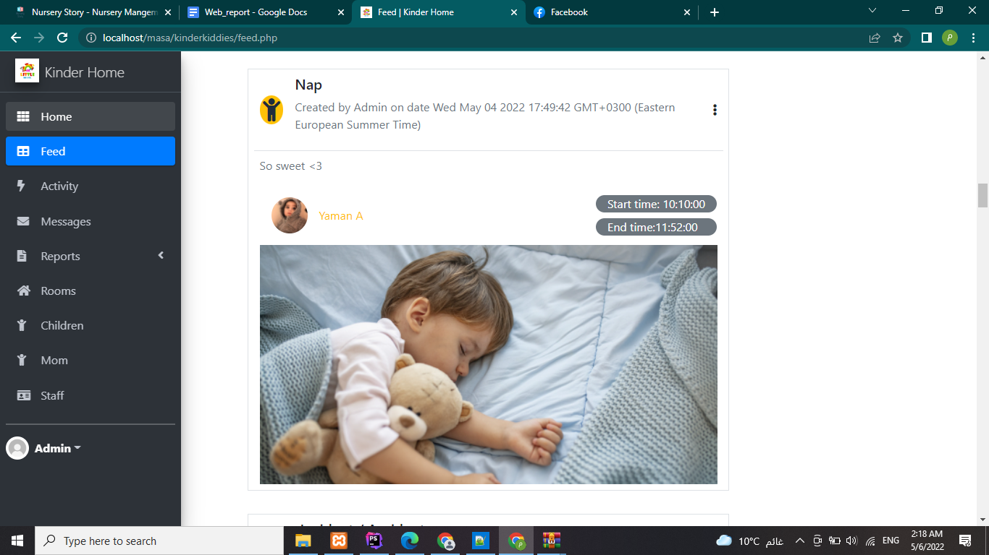third activity is accident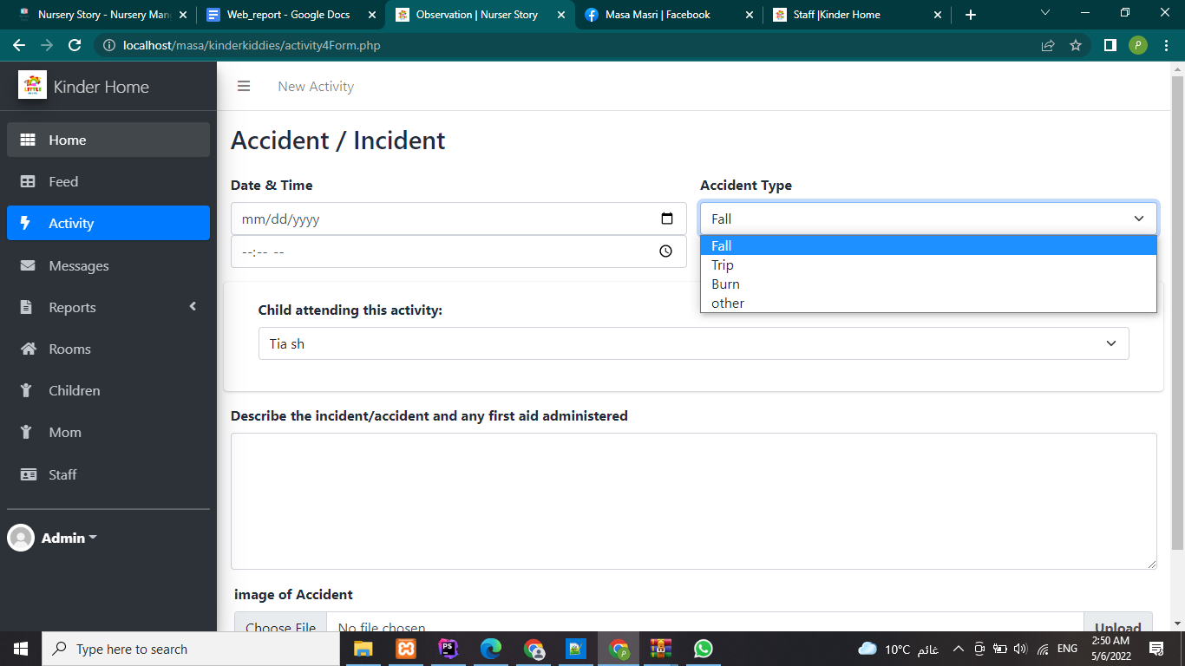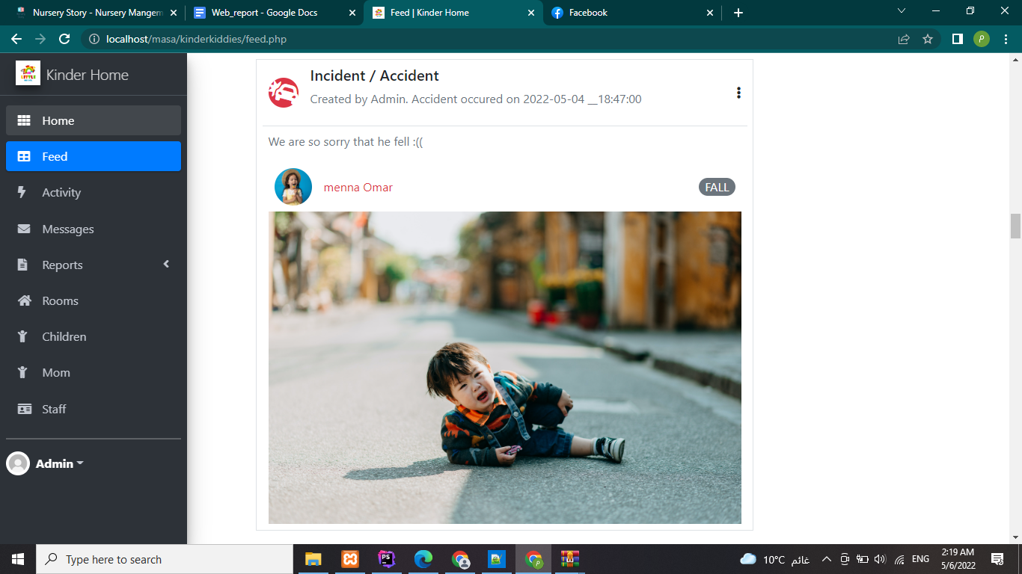The third is general for any learning or development activity chosen by the creator and as food it could contain multiple children.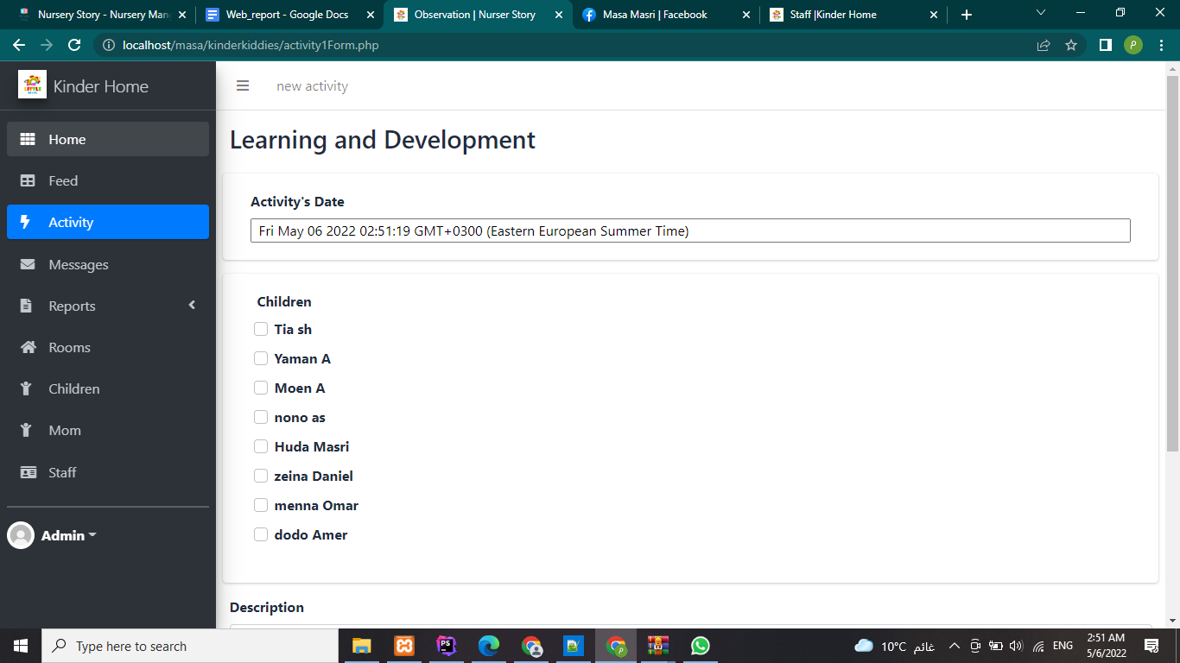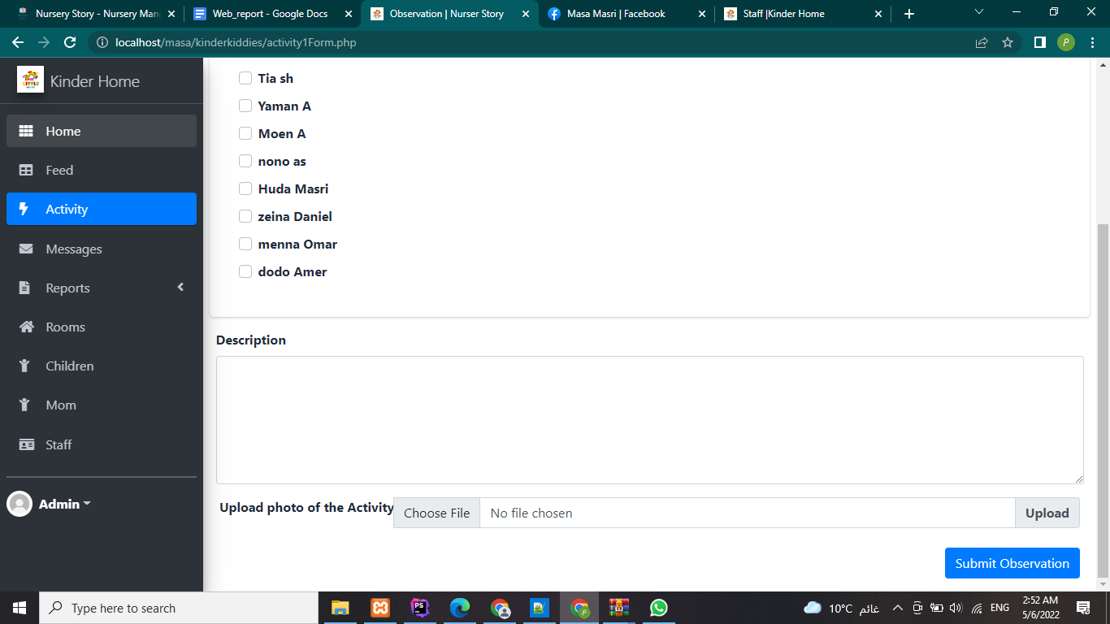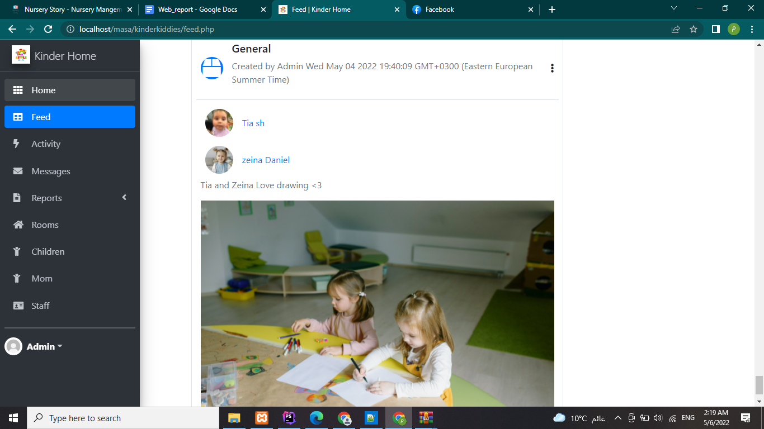rooms section:

Staff of the room first steps

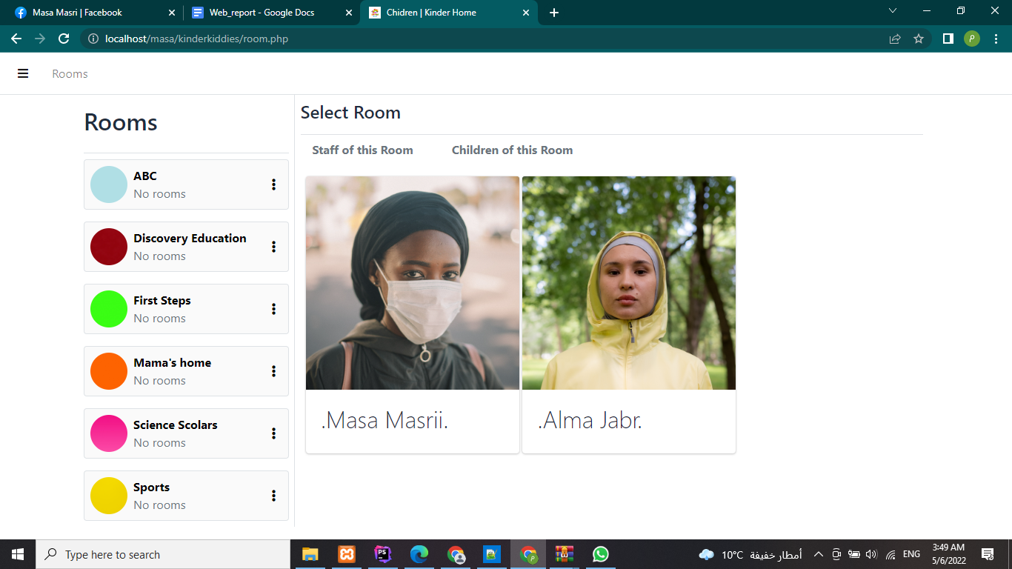children of the same room

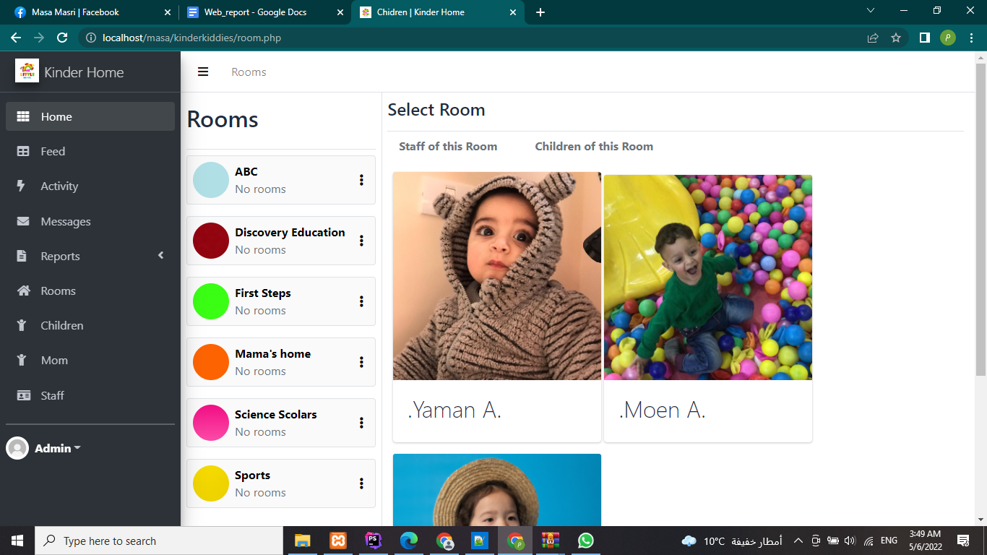

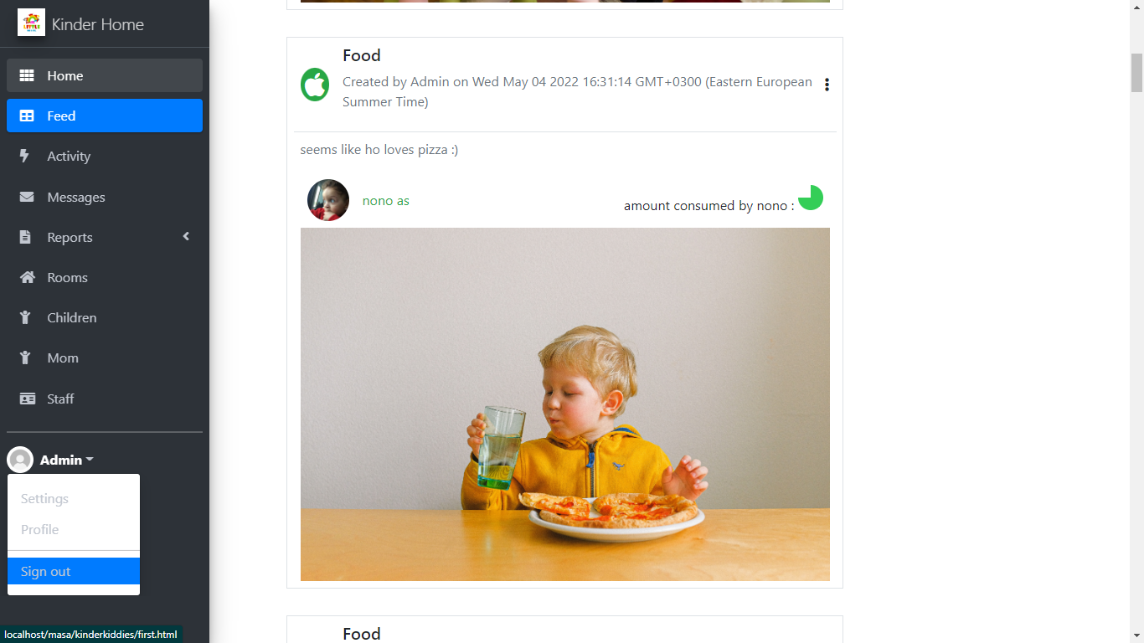Then I signed out from the admin page and logged in to a mom page according to the database id and password of mom.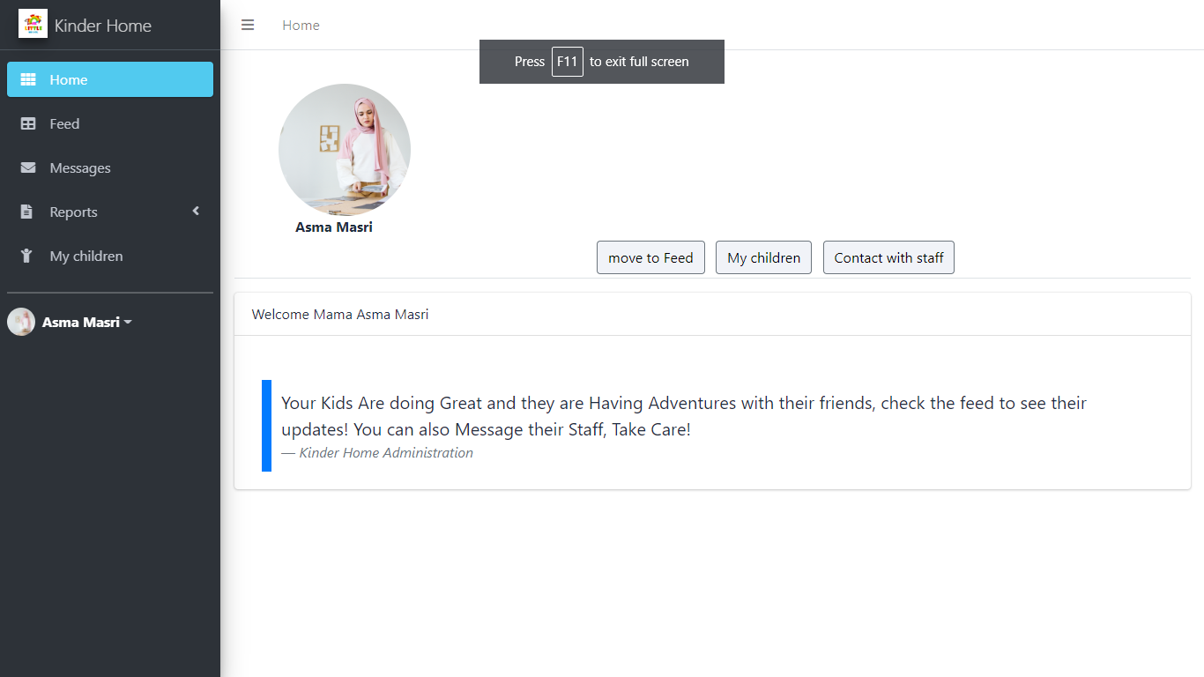Mom can see her kids profiles as follows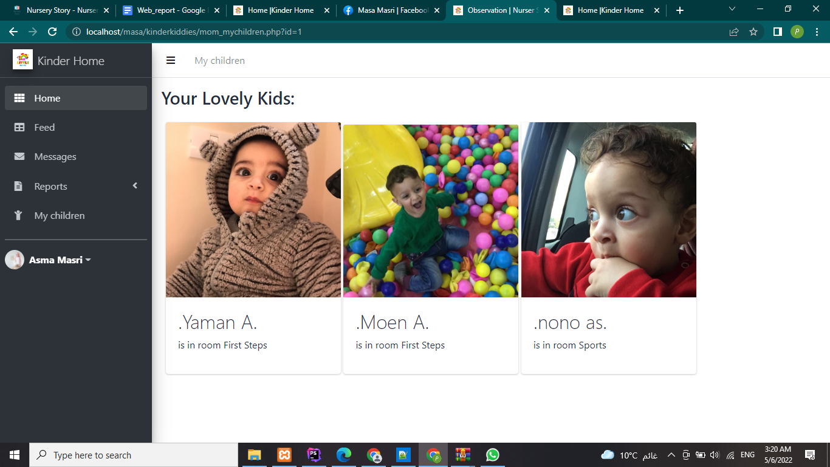and also message admin and staff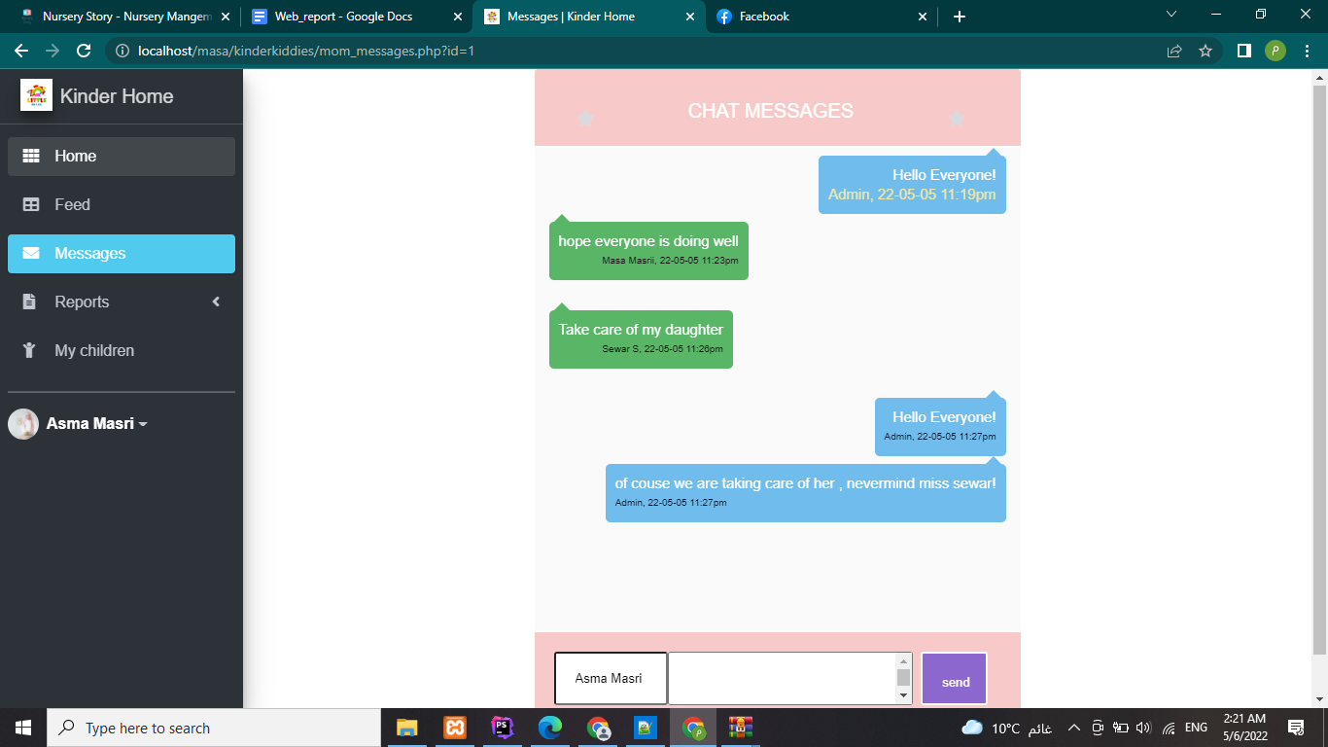and also sees the feed of her kids

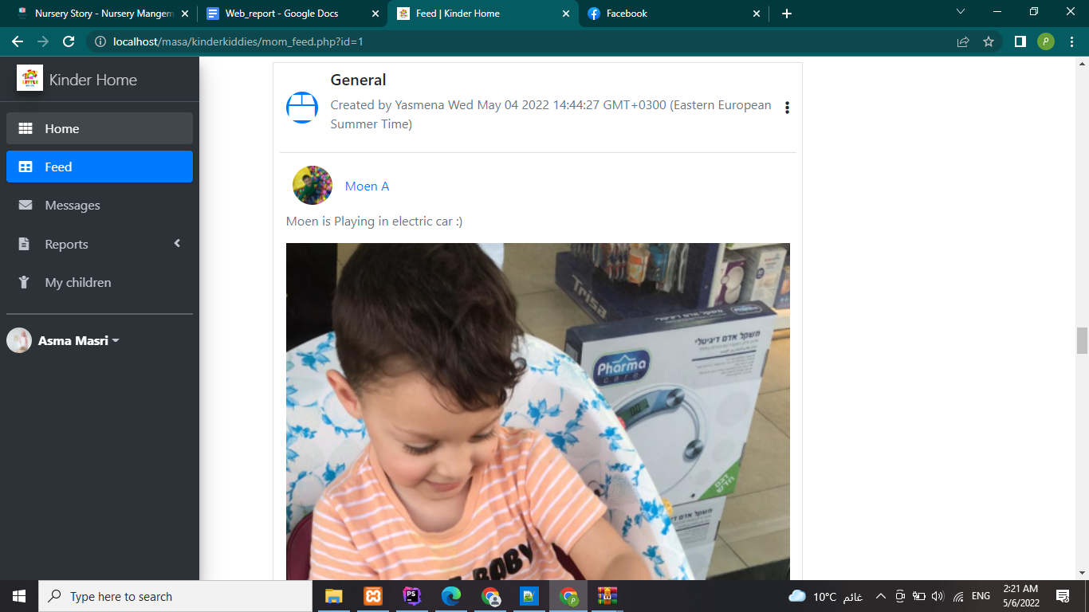3- login as a staff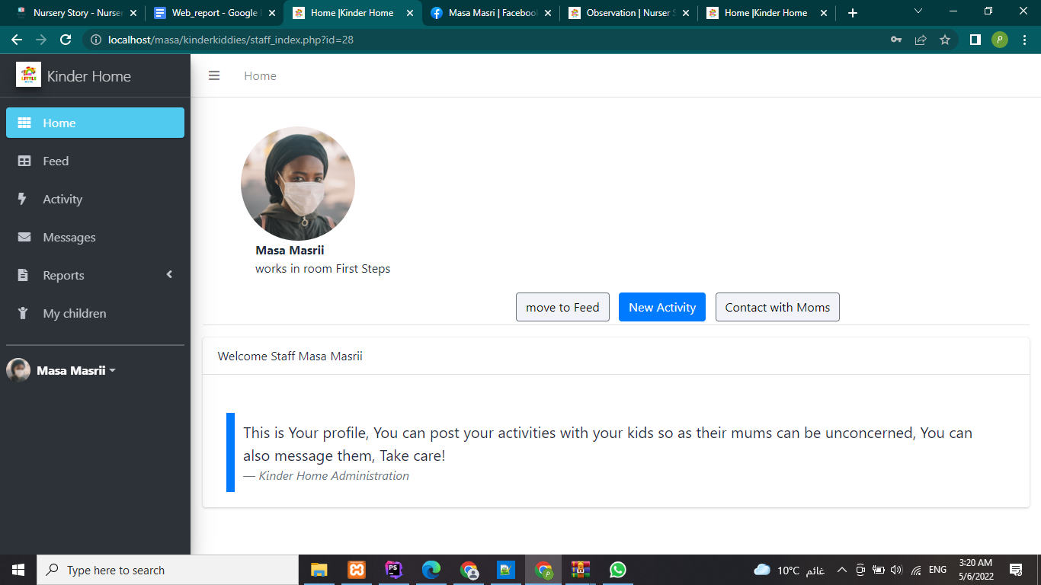a staff has the permission to add activity as the admin. And also sees the feed.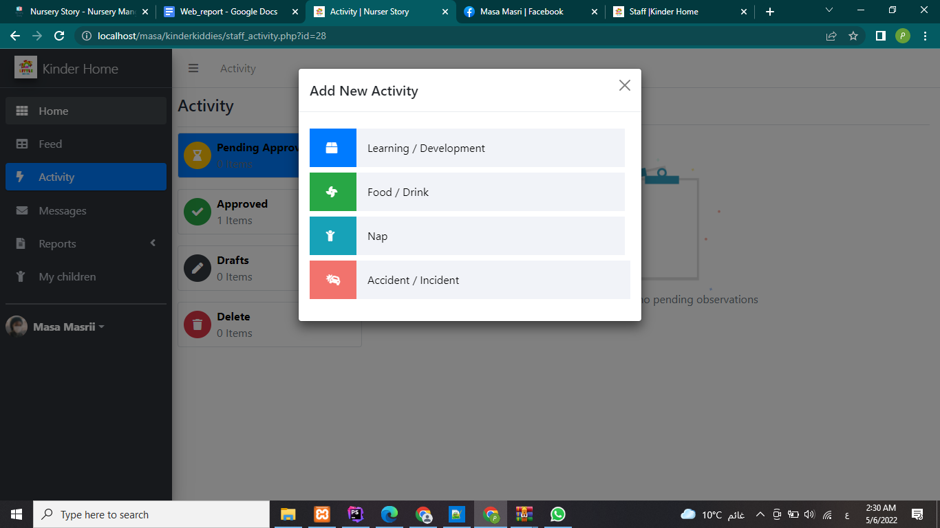They also can see the specific kids assigned in their room.

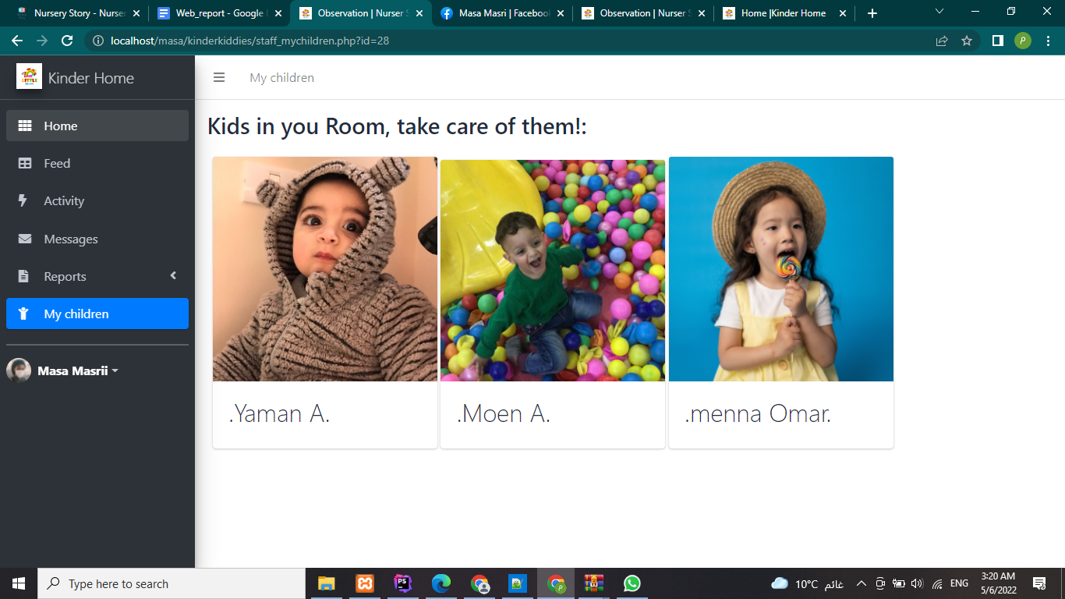

__________________________________________

Also the website is responsive :

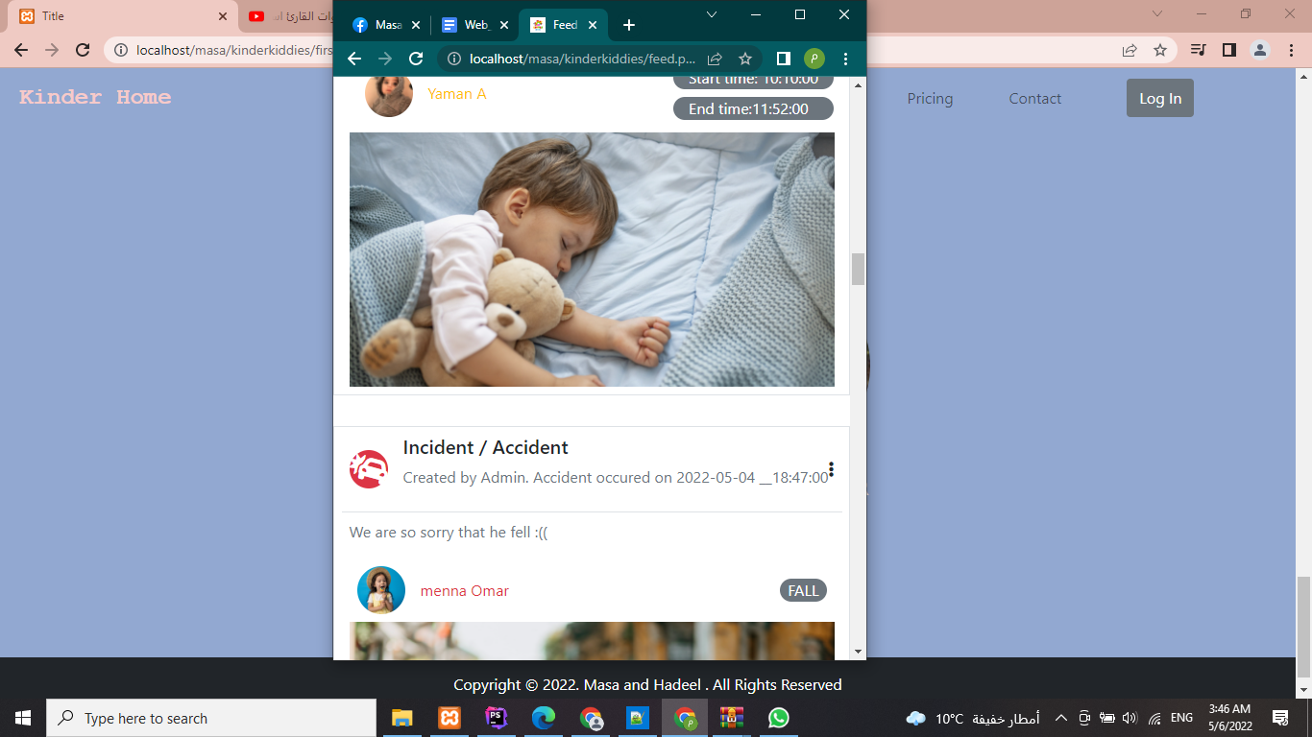

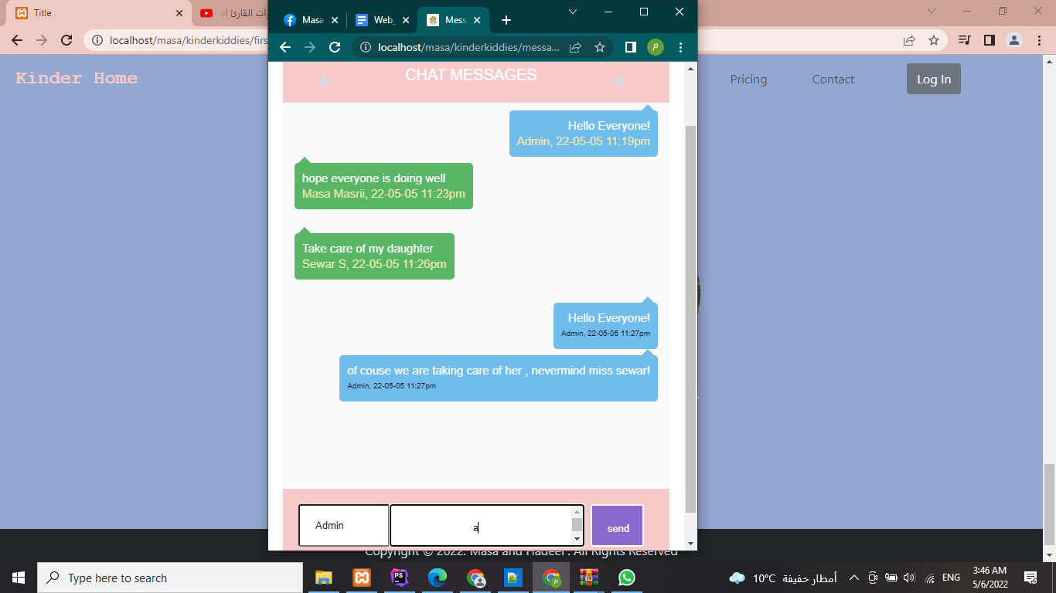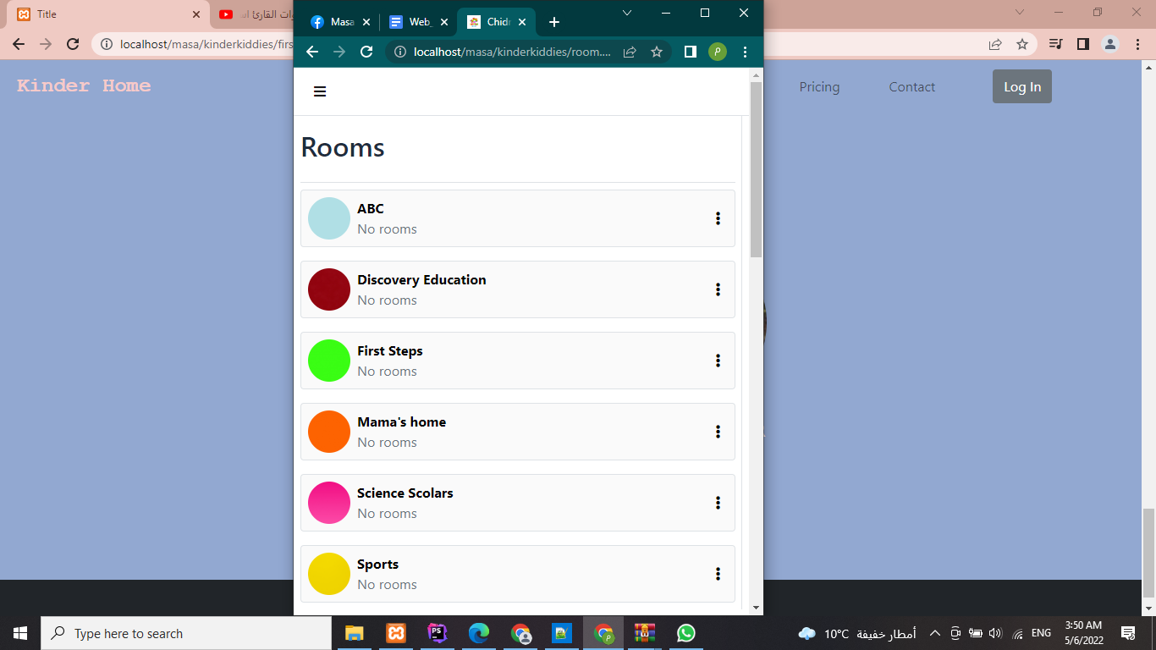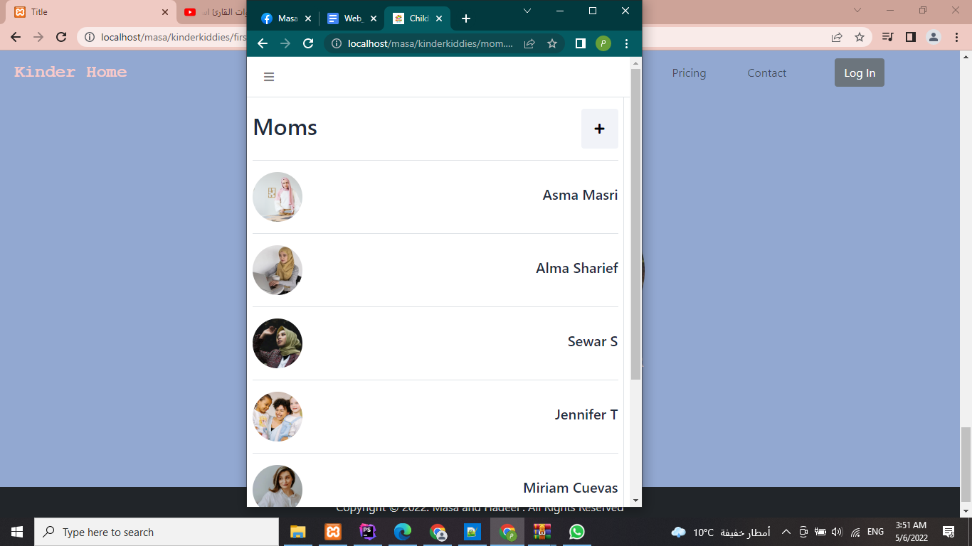

9- conclusion

We conclude that we can solve a lot of problems that we face in real life with a software web development in easy and comfortable interface, as we have kids in our families and as we lack this kind of software management, we struggle and always be concerned about our kids in kindergartens what they ate and how much they ate or slept, This website Have it all.

10- references

* Course slides
* W3schools
* google